Example No 1
Input:
using System;

namespace Abdullah_Sadiq_Cp_Lab_6
{
class Program
{
static void Main(string[] args)
{
for (int i = 0; i <= 10; i++)
{ Console.Write(i + ","); }
}
}
}
Output:
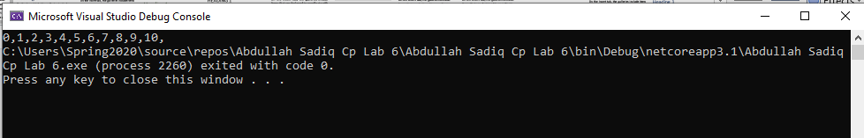
Example no 2
Input:
using System;

namespace Abdullah_Sadiq_Cp_Lab_6
{
class Program
{
static void Main(string[] args)
{
for (int i = 1, sum = 1; i <= 128; i = i*2, sum *=i)
{
Console.WriteLine("i = {0}, sum = {1}", i, sum);
}
}
}
}
Output:
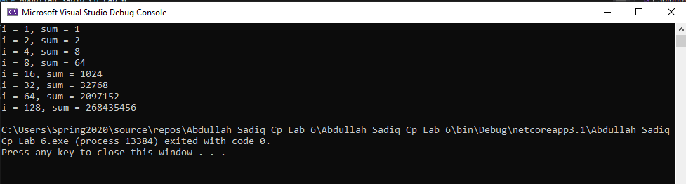
Example no 3
Input:
using System;

namespace Abdullah_Sadiq_Cp_Lab_6
{
class Program
{
static void Main(string[] args)
{
for (int i = 1; i <= 10; i++)
{

Console.WriteLine("2x{0} ={1}", i,i * 2);

}
}
}
}
Output:
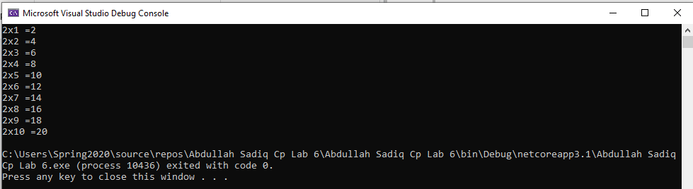
Example No 04
Input:
using System;

namespace Abdullah_Sadiq_Cp_Lab_6
{
class Program
{
static void Main(string[] args)
{
for (int small = 1, large = 10; small<large; small++,large--)
{
Console.WriteLine(small + " " + large );
}
}
}
}

Output:
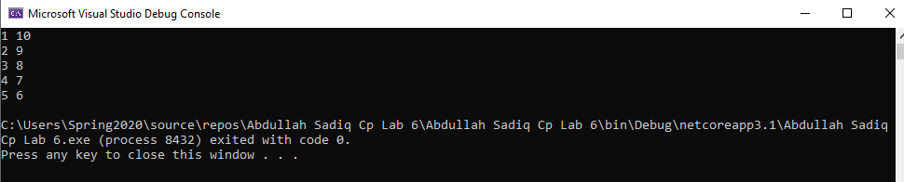
Example No 05
Input:
using System;

namespace Abdullah_Sadiq_Cp_Lab_6
{
class Program
{
static void Main(string[] args)
{
for (int i = 0; i < 3; i++)
{
for (int j = 0; j < 3; j++)
{
Console.Write("*" + " ");

}
Console.WriteLine("");
}
}
}
}
Output:
